**Stages in Crime Scene investigation -**

1. **Secure the crime scene/ Barricade the crime scene With yellow tape Survey the crime scene.**
2. **Observation of crime scene**
3. **Searching the crime scene**
4. **Recognition of physical evidences.**
5. **Documentation of the crime scene / Recording of the crime scene.**

* **Note- taking**
* **Photography**
* **Videography**
* **Sketching**

1. **Collection and preservation of the Evidences.**
2. **Packaging of the Evidences.**
3. **Labelling of the Evidences**
4. **Transportation of evidences**
5. **Chain of custody**

**Searching the wildlife crime scene.**

There are many methods for searching the scene in a logical and systematic way to **locate evidences.**

1. **Line/Strip Search Pattern**

* In the line/strip search pattern, one or two investigators start at the boundary at one end of the scene and walk straight across to the other side.
* This method is best used in scenes where the boundaries are well established.
* Best in large, outdoor scenes.

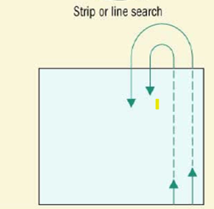

1. **Zone/ Quadrant Search Pattern**

* This search method in which the crime scene is divided into smaller sections (zones or quadrants) and team members are assigned to search each section. Each of these sections can be subdivided into smaller sections for smaller teams to search thoroughly.
* Most effective in houses or buildings. (INDOOR SCENE)

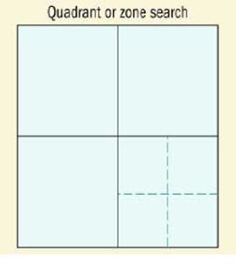

1. **Grid Search Pattern**

* The grid search pattern employs two people performing line searches that originate from adjacent corners and form perpendicular lines.
* One searcher will move in a north-south direction while a simultaneous search is conducted in an east-west direction.
* Both move back and forth as in the line/strip search pattern.

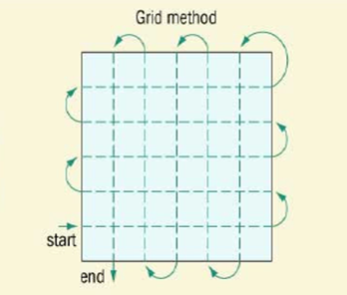

1. **Spiral Search Pattern**

* This search method in which the investigator moves in an inward spiral from the boundary to the center of the scene or in an outward spiral from the center to the boundary of a scene.

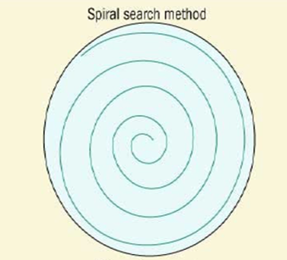

1. **Wheel/Ray**  **Search Pattern**

* A search method employed by several people who move from the boundary straight toward the center of the scene (inward) or from the center straight to the boundary (outward).

**Documentation of the crime scene / Recording of the crime scene.**

* After securing and searching of crime scene, documentation is done.
* Documentation is the most crucial step.
* It provides the permanent record of condition of crime scene and its physical evidences.
* It also helps in reconstruction of the crime scene.
* It includes 4 methods:-
* **Note- taking**
* **Photography**
* **Videography**
* **Sketching**

1. **NOTE-TAKING**

* It is written record about each and everything in a chronological order.
* The note-taking process begins with the call to a crime-scene investigator to report to a scene.
* The first notes should identify the person who contacted the investigator and record the time of the contact.
* When the lead investigator arrives, the note taker should record the date and time of arrival.
* If additional personnel are contacted, their names, titles, and times of arrival should be recorded.
* It is also important to record the tasks assigned to each member of a team, as well as the beginning and ending times of the processing of the scene.
* The investigator should take note of condition of the crime scene.
* The notes should be in ink (preferably black or blue) and written in a bound notebook.
* Most important, notes should be written at the time of the crime-scene investigation, not left to record from memory at a later time.
* The investigator should note whether any evidence was disturbed by emergency medical personnel, a suspect, or investigative personnel.
* The notes should describe the animals body appearance and record the position of the body and any visible wounds, injury or blood spatter.

1. **PHOTOGRAPGHY**

* It provides the permanent record of condition of crime scene and its physical evidences.
* It also helps in reconstruction of the crime scene.
* It is a permanent record of the crime scene.
* Creates a mental picture of the scene for those who are not present.
* Crime scene and evidences should not be touch or move before taking the photographs.
* It involves 3 methods that is - Overview Photographs, Medium-Range Photographs, Close-up Photographs.

**Overview Photographs**

* The first pictures the photographer takes are overview photographs of the entire scene and surrounding area, including points of exit and entry.
* The photographs must be taken from various angles.
* If the crime took place indoors, the entire room should be photographed to show each wall area.
* Rooms adjacent to the actual crime site must be similarly photographed.
* If the crime scene includes an animal body, photographs must show the animals body’s position parts and location relative to the entire scene.

**Medium-Range Photographs**

* The next set of pictures should be medium-range photographs that show the layout of smaller significant areas of the crime scene.
* Medium-range shots should be taken with evidence markers.

**Close-up Photographs**

* The last method is close-up photographs of evidences with and without scale.
* The pictures must be taken at a **90-degree angle** to the object or evidences, with and without evidence markers and scales.
* After the 90-degree photographs have been taken, photographs from other angles may be taken.
* All evidences including parts of animals must be photographed with different angles
* The injuries and wounds of the animals must be photographed.
* If any weapons like knife, gun lying near a body must be photographed.

1. **Videography**

* The use of digital video recording at crime scenes is becoming increasingly popular because the cost of this equipment is decreasing.
* Video recording should include the entire scene and the immediately surrounding area.
* Long shots as well as close-ups should be taken in a slow and systematic manner.
* It is desirable to have one crime-scene investigator narrate the events and scenes being taped while another does the actual shooting.
* Only the narrator’s voice should be heard, and no personnel should be in the shots. (No extra background noise).

**Crime scene Sketching**

* Once the crime-scene investigator has taken notes and photographs, sketching of the scene should be done.
* Sketch can clearly show the layout of an indoor or outdoor crime scene and illustrate the location of collected evidences.
* It relates the sequence of events at the crime scene.
* Establishes the precise location and relationship of objects and evidence at the crime scene.
* It is a permanent record of the crime scene.
* Creates a mental picture of the scene for those who are not present.
* **All sketches must include the following features**: -

• The title block contains the case number, the name and title of the artist, the location of the scene, and the date and time at which the sketch was created. It The title block should appear in the lower right corner of the sketch paper.

• The legend should contain the key to the identity and dimensions of objects or evidence and may be represented by symbols, letters, or numbers.

• The compass should show an arrow to denote north in relation to the scene.

• The body of the sketch contains the drawing itself and all dimensions and objects located within it.

**TWO TYPES OF SKETCH**

1. **The Rough Sketch –**

* The rough sketch is the first sketch created at the crime scene with accurate depiction of the dimensions of the scene and showing the location of all objects.
* It is drawn without scale at crime scene.

1. **The Finished Sketch –**

* The finished sketch is constructed with care and concern afterward not at crime scene.
* The finished sketch must be drawn to scale.
* A final sketch can be done by an investigator or a hired professional.
* It can be done by hand in pen or by computer

(**Computer-aided drafting (CAD)** is designed computer software for reconstructing crime scenes from rough sketches. )

**Four Measurements methods of sketching -**

Measurements should be taken from the fixed points to pieces of evidence first.

1. **The rectangular method –**

* The rectangular method measures two distances to an object that make a right angle with each other and to two fixed, flat surfaces. Two fixed point can be tree or wall.

1. **The triangulation method –**

* The triangulation method measures the distance of the object from two fixed points of known distance from each other. This forms a triangle.

1. **The baseline method-**
2. It is especially useful for outdoor scenes. First, two fixed objects on opposite sides of the scene are located (designated A and B). A line is then made between them and measured.
3. Each object or piece of evidence has a line drawn from it to the baseline to make a 90-degree angle with the baseline.
4. The distance of the line from the object to the baseline is then measured, along with its point of intersection with the baseline.
5. **The polar coordinates method –**

It uses only one reference point. The sketch shows the distance and angle at which an object is located in the scene relative to the reference point